THIS EXCITING INITIATIVE IS NOW LIVE.
GO TO
https://bit.ly/3FbC5rt
FOR FURTHER INFORMATION
BRITISH HORSE FOUNDATION: BETTER BEGINNINGS PROGRAMME
What is the Better Beginnings Programme?
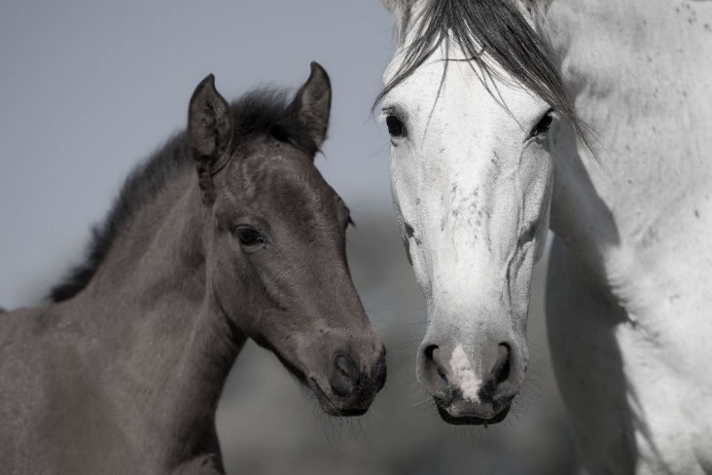
The British Horse Foundation Better Beginnings programme was borne from an awareness gained over decades in the industry that young horse production has not developed at the same rate as other areas of equestrianism. This has been brought into sharp focus recently. Equestrianism is at a pivotal point. The importance of the public perception of equestrian activities and the social licence to operate has never been higher. The BHF believes that the production of the young horse, from inception to 2 years old, is of vital importance in safeguarding their wellbeing throughout their lives. A happy, healthy, and well-educated horse promotes equestrianism in a positive way to all.
The Starting Point
The first event in this programme was a roundtable meeting held at Weatherby’s in October 2022 at which we had expert speakers discussing such subjects as:
- Fit for Purpose – what it means, what it looks like, how to achieve it.
- Genetics and ‘Omics’ - genetic diversity, the contribution of the mare, the contribution of the stallion, the characterization and measurement of our biology that translates into the structure, function, and dynamics of the being.
- Management - with a focus on the happy equine who will be fit for purpose with longevity in mind.
- Mental health - focussed on how best to prepare young horses for the world in which they must function and thrive.

This was the first building block in the programme and its aim was to:
- inspire everyone to look critically at their role in equine development,
- identify the gaps in knowledge and understanding in their sphere,
- take ownership and
move forwards with a vision of creating top class British Bred horses for all equestrian activities. In the words of the BHF Chair Dr Jane Nixon ‘Improved education and teamwork are crucial to providing young horses with a start that will set them up for happy, healthy, and sound lives long into the future.’
Moving On
The Better Beginnings: ‘Your opinion matters’ webinar in December 2022 was the second event in the series organised by the BHF as part of the Better Beginnings programme. This time, an impressive array of expert panellists answered questions posed by attendees. It proved very popular and the organisers received some excellent questions which really allowed the panellists to get stuck into the topical issues in young horse production and development. The questions, answers and feedback from this session were then triaged and collated -- along with the information from the initial event -- and together they have formed the basis of a best practice guide for young horse development, which will be launched on 9th October 2023.
Better Beginnings: From Inception to 2 Years Old
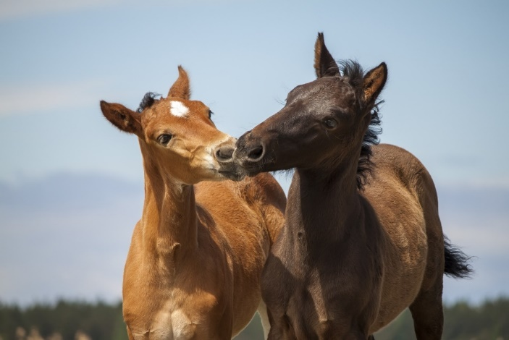
The guide is split into 8 Advice Notes, which break the information down into bite size chunks adding valuable new information that can be consumed by anyone, whether they are just interested in breeding, are a first-time breeder or a stud owner. The Advice Notes and their accompanying links will direct them to several carefully curated outside sources, which include the recordings of the experts from the roundtable event as well as Pony Club webinars which give an overview of the basics of breeding. Each Advice Note focuses on specific action points that may challenge accepted thinking and long held beliefs.
Jane Nixon encourages this approach and explains that ‘Changing long held practices and beliefs and even changing the way we look at what we do is difficult but, where we can make small changes that will improve the lives and wellbeing of our equine partners, it’s up to us do everything we can. ‘
The BHF believes that those working through the programme will find the Advice Notes helpful in guiding them through the first step in this process. By acquiring the skills that will enable them to critically assess their own current individual beliefs and practices they will then be able to assess the current research and understanding in the field and apply it to their own breeding and youngstock development programme and thus improve the quality of breeding and youngstock development nationwide.
Thank you for your support.
Keep an eye on our website and Facebook page for more information.
https://www.britishhorsefoundation.org.uk/programs

