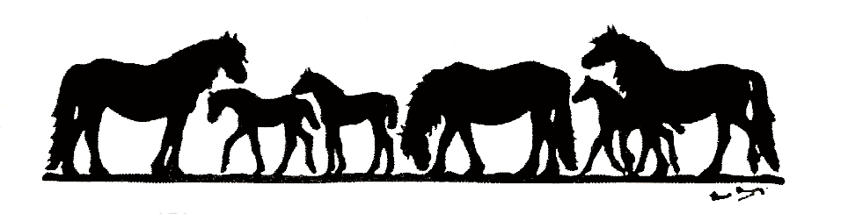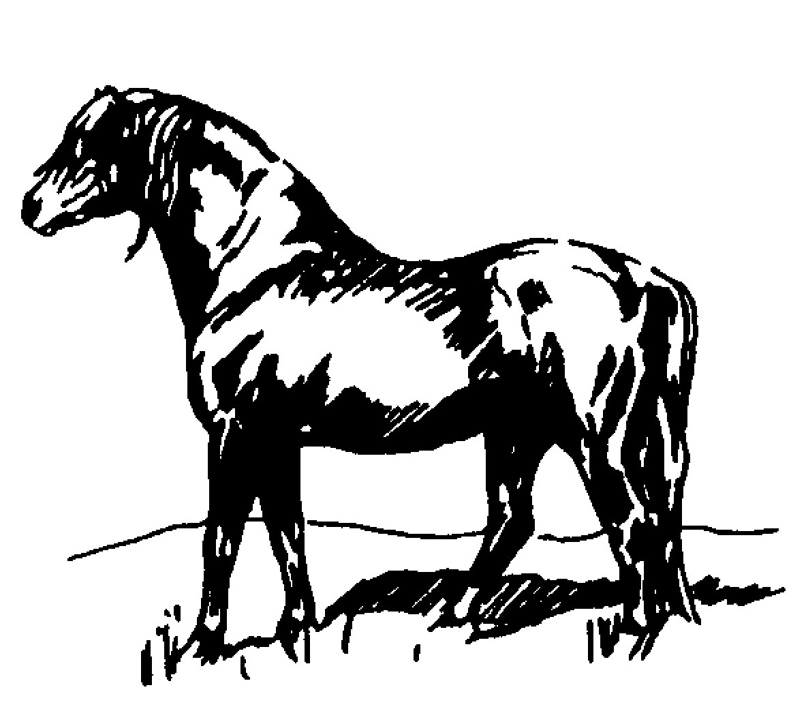
Study Day
(open to Panel Judges, Probationer Judges and anyone interested in becoming a Judge)

At Newton Rigg College, Penrith, Cumbria. CA11 0AH
Sunday 15th April 2018
10.30am to 3pm

The Fell Pony Society and The Northern Dartmoor Group have joined together to organise a Judges’ refresher day to remind Judges and other interested parties on breed type, characteristics and conformation. There will be an extra section on judging a Worker Hunter pony class.

Open to all NPS Mountain & Moorland, BSPS Heritage and Breed Panel Judges, probationary and potential Judges. We also warmly invite anyone who has an interest in our breeds, whether showing inhand/ridden or breeding.

There will be no charge for current Panel or Probationer Judges. Other interested parties are most welcome to attend and a donation of £5, to cover some of the cost, would be most appreciated.

Programme and Speakers
The Fell Pony
Alistair Smith and his family have been breeding Fell Ponies for over thirty years (Bracklinn Stud), he has an extensive knowledge of the breed, winning at the FPS stallion show four times, and last year he qualified his homebred stallion for the prestigious Cuddy In-Hand Championship at the 2017 Horse of the Year Show. Alistair is on the Fell and Dales pony Judges’ panels. On the back of his 2017 Cuddy attendance, who better to share his knowledge with us by giving a breed talk on type and conformation.

The Dartmoor Pony
Madge Taylor is a renowned breeder of Dartmoor Ponies (Langfield Stud), and is an NPS Judge as well as being an A panel breed Judge. In 2017 Madge judged the M&M WHP at the Horse of the Year Show and has had great success in the past including winning the overall M&M title at Olympia with Langfield Canth. She has an extensive knowledge of the breed and shows in-hand and ridden to the highest standard. We are very lucky to have Mrs Taylor to come and present to us.

Judging a M&M Working Hunter Pony
Russell Sutcliffe and Peter Boustead have both been renowned Judges of M&M NPS Worker Hunter Pony classes and championships for many years. Who better to give us a talk and answer questions on this topic? We look forward to gaining more knowledge about Fell and Dartmoor ponies from Russell and Peter, whilst learning about the key elements to remember when competing in a WHP class.

Please would you email your intention to attend by Saturday 7th April 2018 to:

Jane Rawden: Tel 07970297642 Email: Janerawden@inspiration-teal.com
Michael Goddard: Tel 07964 209243 Email: g.michaelrichard@yahoo.com
Ann Rigby: Tel 07758 002805 Email: daisymead@tiscali.co.uk

