Centenary Commemoration
Her Late Majesty Queen Elizabeth II - 21 April 2026
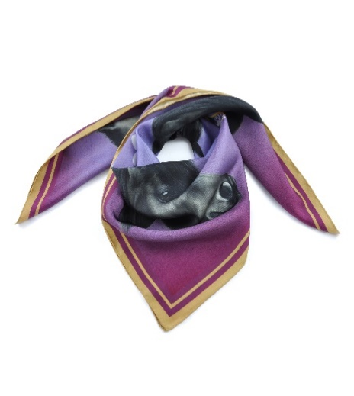

To commemorate the 100th birthday of Her Late Majesty Queen Elizabeth II, Patron of the Fell Pony Society for over forty years, we are offering members and friends the chance to purchase one of the few remaining limited-edition Centenary Celebration scarves. The original design was created as a personal gift for Her Late Majesty and presented to her at the Royal Windsor Horse Show 2022.

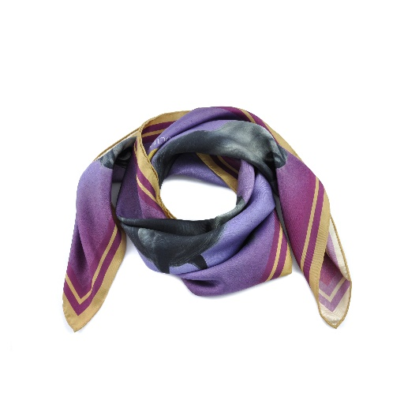
Development of this unique and beautiful item was an eighteen-month labour of love from the initial idea to production. Artist and native pony breeder Laura Pennell designed the piece around a portrait of Carltonlima Emma, Her Late Majesty’s much-loved Fell pony. Laura also wove in further meaning with the tiny white flower of Grass of Parnassus, which is known as the ‘flower of Cumbria’, and a nod to the heritage of the Fell pony.

In collaboration with silk printer Samuel Petty, of Worcestershire based David Watson silk printers, the final touch was to include a double band of gold round the edging of the scarf, which tied in with the Queen’s racing colours and gave the scarf a luxurious, very special celebratory finish.

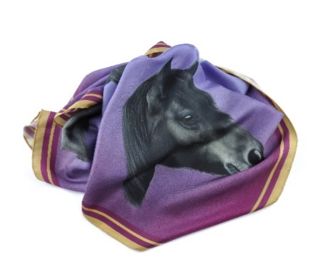
Purchase of the remaining scarves will be by auction, and bids should be submitted by email to fpsauction@yahoo.com between 20 April 2026 and midnight on Sunday 26 April. The scarves will be sold to the highest bidders, subject to a minimum bid of £20 per scarf.
Postage and packing will be free within the UK for successful buyers. Buyers outside the UK will need to add an additional P&P charge: USA £21.85, Europe £12.35. (For all other destinations, please contact the FPS office before bidding.)

Good Luck and Happy Bidding!

