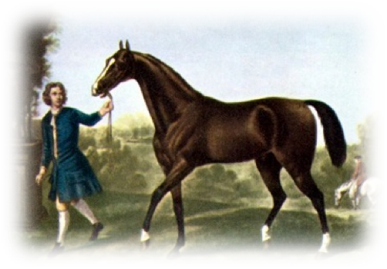
Horse genealogy research
Aim: Genetic tracing of founder sires in modern Horse Breeds
Project title: Northern European horse breeds: a close look on their ancestry from the male perspective
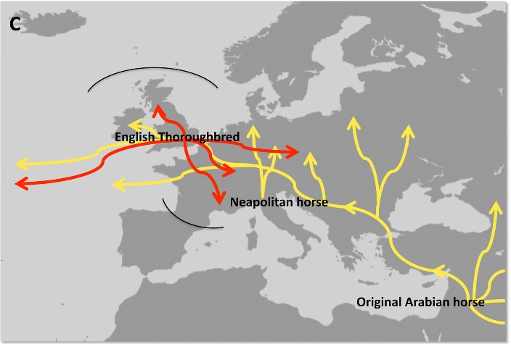
Story: Horse domestication (5,500 years ago) coincided with the rapid development of human civilisation. While horses served initially as a food source, the horse soon revolutionised agriculture, transportation and warfare. Today there are 58 million horses worldwide and over 700 horse breeds. Modern horses are genetically different from their ancestors due to breeding from a limited number of stallions which started during the Bronze age. Male specific genetic information is inherited directly form the father to the son and can be used to trace the history of the male line.

Recent studies have shown that the majority of paternal genetic information of modern horse breeds originates from oriental stallions. The male line of the: Shetland Pony, Icelandic horse, Norwegian Fjord and Swedish Coldblooded horse however, have not been influenced by Oriental stallions. Currently, little is known about the genetic paternal history of native British breeds. Northern European breeds may therefore play a vital role in the discovery of ancient migratory pathways and studying these breeds could provide a fundamental link between the modern horse and horse ancestors.
We are studying the migratory pathways of native British breeds and we require your help. Our research team require hair samples and pedigree information from male British native horses (gelding, colt or stallion). Every contribution we can get is valuable to us and will help us to unlock the history of our native horses. Samples and pedigree information will be confidential and only used for the male specific ancestry project.
We would greatly appreciate your participation and support.
Many thanks,

Lucy Allen Dr. Barbara Wallner
Research student Principle Supervisor
Tel number: +447901774538 barbara.wallner@vetmeduni.ac.at
Lucy.Allen@student.rau.ac.uk

