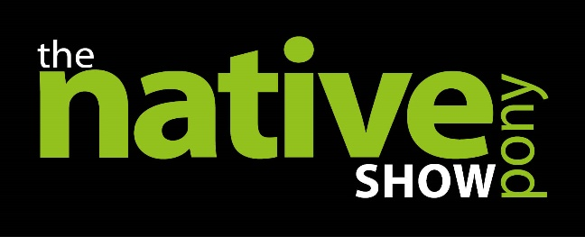
FOR IMMEDIATE RELEASE
January 2018

NEW NATIVE PONY SHOW FOR 2018!

Native Pony Magazine have launched a new event for 2018, The Native Pony Show, to be held on 28th April 2018 at West Wilts Equestrian Centre, Wiltshire, BA14 6QT. The unaffiliated show will allow competitors to take part in breed specific in-hand, mixed ridden and working hunter classes. Open to all registered M&M breed owners, the Native Pony Show is anticipated to be a great day for participants. As the show is being held two weeks before Royal Windsor, it is also a great opportunity for competitors to use is as a warm up!
The Native Pony Show is an unaffiliated showing show run exclusively for Mountain and Moorland Breeds. This is a great opportunity for people to get out and about with their natives and enjoy a fun showing environment. There are over 70 classes for people to select from and the show will really offer something for everybody. All entrants will have the opportunity to compete for the Native Pony Magazine Supreme of Show as well as various class championships throughout the day. In true Native Pony style, there will be fantastic rosettes and sashes to be won.
Judges have been announced for the show and are a line-up of affiliated panel judges that will offer competitors a great wealth of knowledge and experience in the ring. A full schedule is available to download from www.thenativepony.com and entries are currently being taken for all classes. Competitors can enter in advance via post or online at redpin.lite.events, pre-entries will close on 23rd April 2018 and entries will be taken on the day.
Sara Haines, Editor of Native Pony Magazine, said, “This event is really exciting for us and fits perfectly with the magazine and our promotion of M&M breeds. There has been a great response for people so far and the support we have received is really positive. We are hoping that this will become a regular fixture in the equine calendar.”
Sponsorship opportunities are available with chances to promote your business or stud through ring, class or championship sponsorship. For more information about the Native Pony Show please contact Briony Simpson on 01380 730888 or email brionysimpson@redpin.co.uk

ENDS

For more information contact Briony Simpson 01380 730888 brionysimpson@redpin.co.uk

