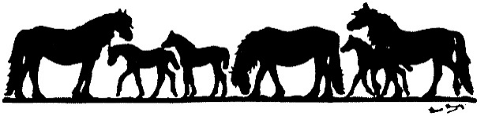
Fell Pony Society Promotions Team Pleasure Ride 22nd April 2018
Millstones, Bootle, LA19 5TJ

Please send all entries to: Susan Brunskill, Ling House, Southwaite, Carlisle CA4 0JH
All ride info such as maps etc. will be put on the Fell Pony Society Website and on the Promotions Team Facebook page if you wish to have yours posted to you, please include a SAE.
Entries close 8th April. Please make all cheques payable to FPS Promotions Team
Name of rider | Name of pony | FPS membership number | Class number | Entry Fee £15 per pony  £12 lead rein

Address:…………………………………………………………………………………………………………………………………………………………
………………………………………………………………………………………………………………………………………………………………………
Contact number:……………………………………………………………… Email:………………………………………………………………
Emergency Contact (To use on day of ride if need be):…………………………………………………………………………….
Disclaimer of Liability. So far as permitted by law the FPS Promotions Committee and Organiser/s will not be liable to any person whosoever whilst upon, entering, or leaving the pleasure ride for any loss, damage, death, injury or accident to persons or property or for lost or stolen items.
All exhibitors must have 3rd party liability insurance. If you are not a member of the FPS please enclose a photocopy of your public liability insurance.
Correctly secured Skull Caps/Riding Hats that meet one of the following current Safety Standards/specifications MUST be worn by all Riders of all ages. All PAS 015; VG1; (BS)EN1384 2017; ASTM F1163 04a onwards; SNELL E2001; SNELL E2016; AS/NZS 3838 2003 onwards.

Signed:…………………………………………………………………… Date:…………………………………………..
Parent/Guardian (if rider is under 18):…………………………………………………………..
Name of accompanying adult if Child is under 12:…………………………………………….

